Implement and Verify Site-to-Site VPN

Connectivity in Azure

* Let we implement site –to-site VPN connectivity from Azure to Local Server.

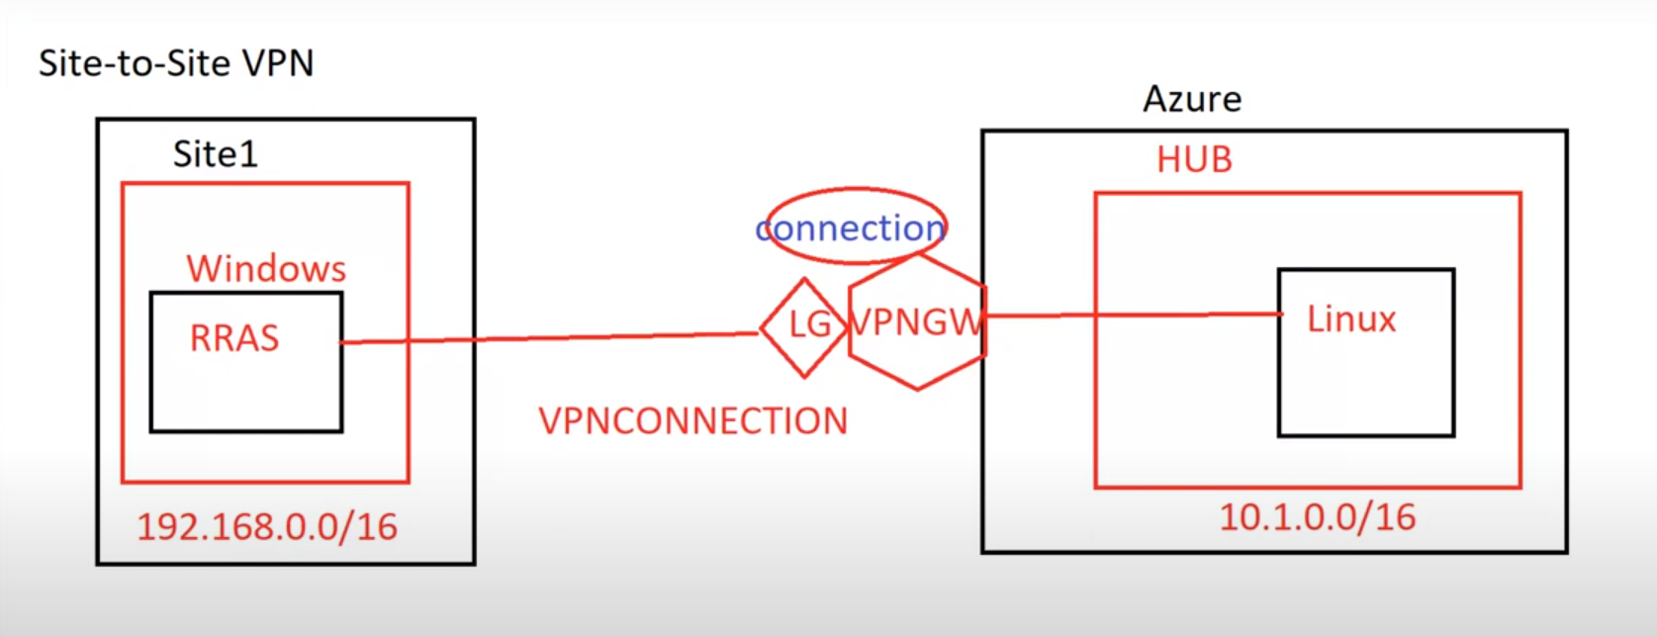

Create a Resource Group:

* Log in to the Microsoft Azure Portal.
* Select the resource group then create it. And another resource group create.

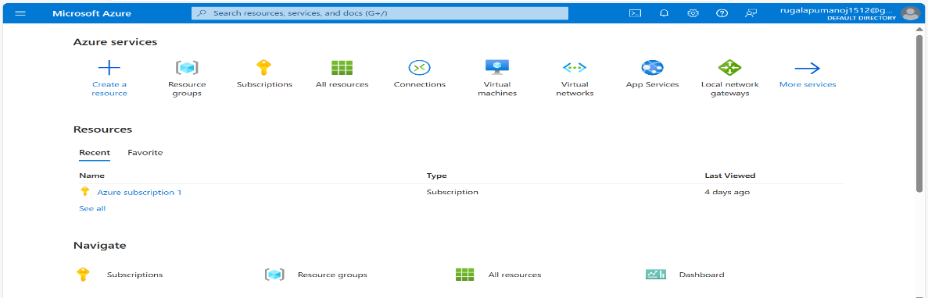

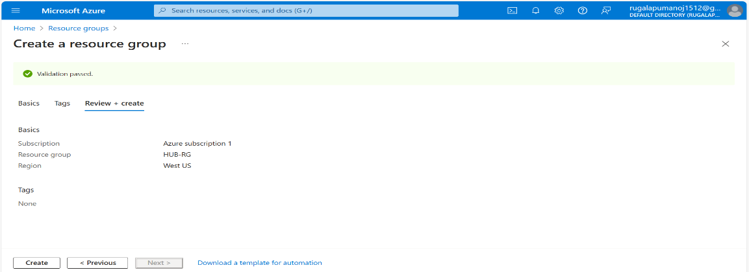

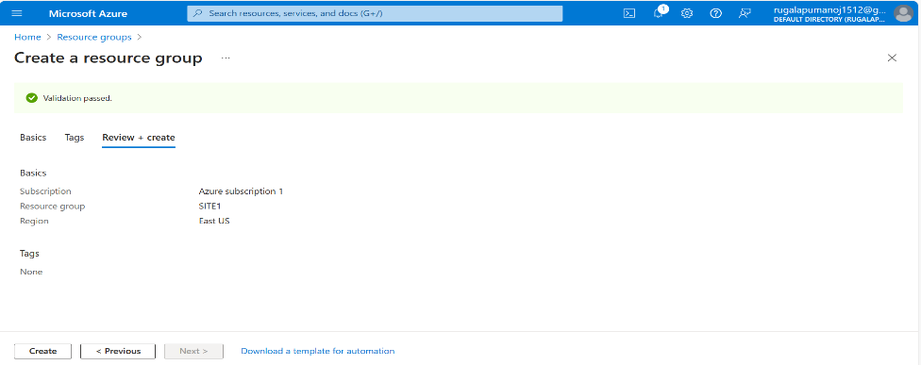

Create a Virtual Private Cloud (VPC)/ Vnet:

* Create a two virtual networks.
* One virtual network in resource group(Hub-RG).

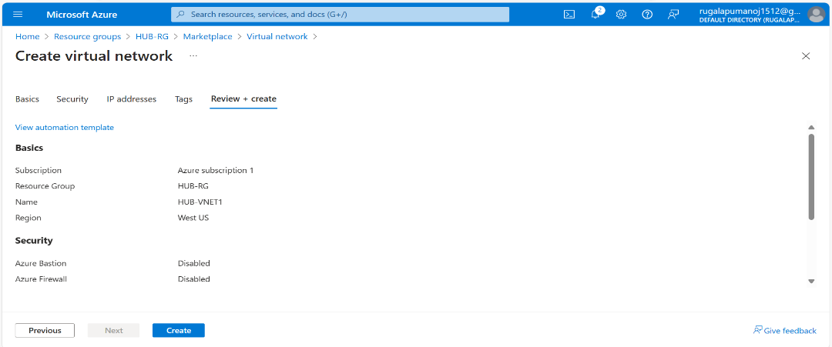

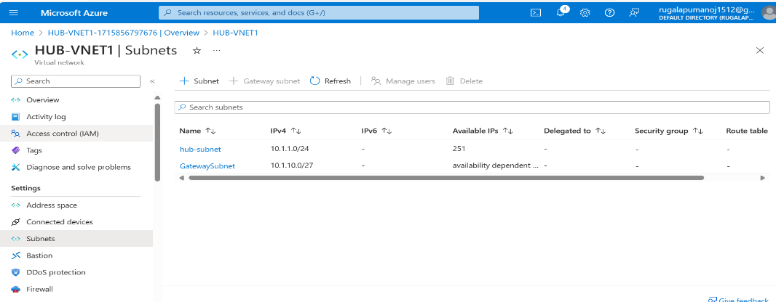

* Another one virtual network in resource group(Site1).

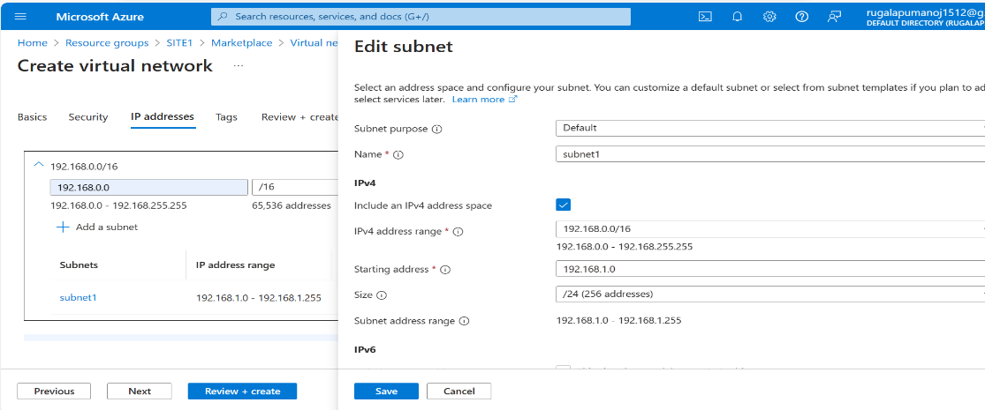

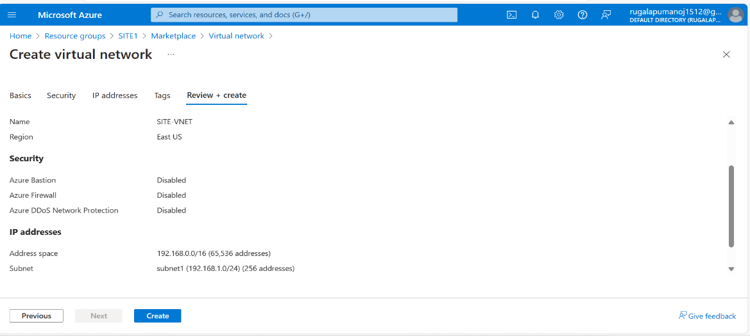

Create a Virtual Network Gateway:

* Select the virtual Network Gateway.

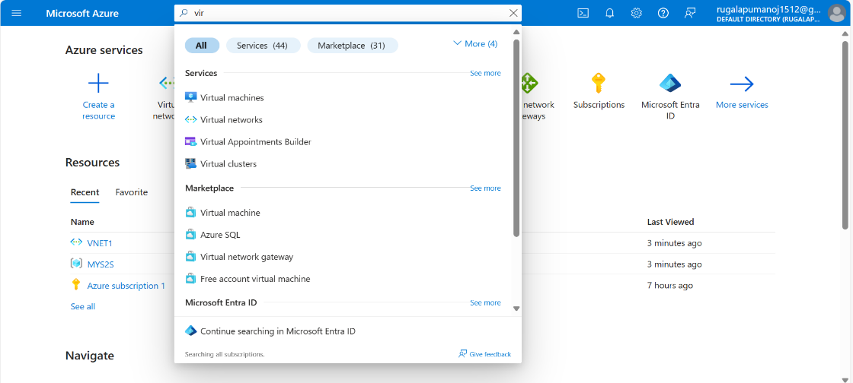

* Fill the details and select your preferred region.

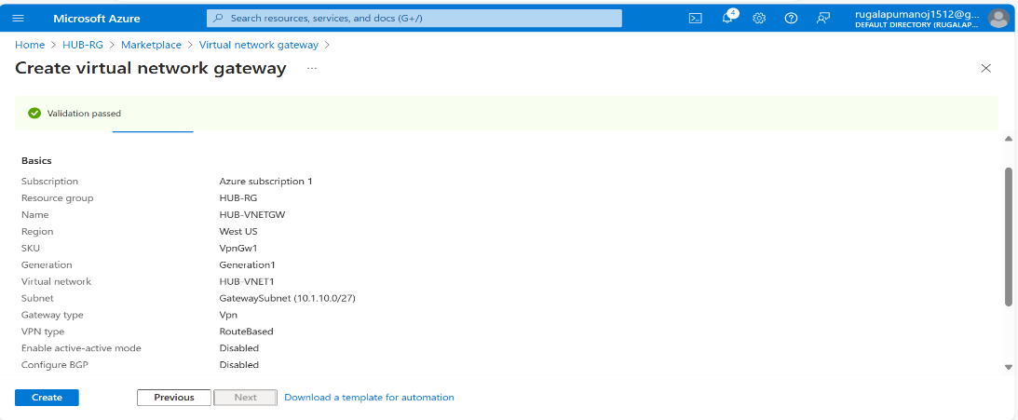

* click “review + Create” and then “create” to create the VNET Gateway in (Hub-RG).

Create a Virtual Machine:

* Create a two Virtual Machine.
* One virtual Machine is Ubuntu server in (Hub-RG) resource, Then create it.

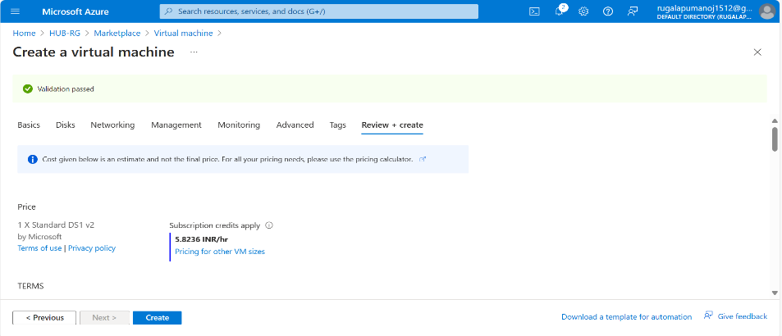

* Another one Virtual Machine is Window Server in (Site1)resource,Then create it.

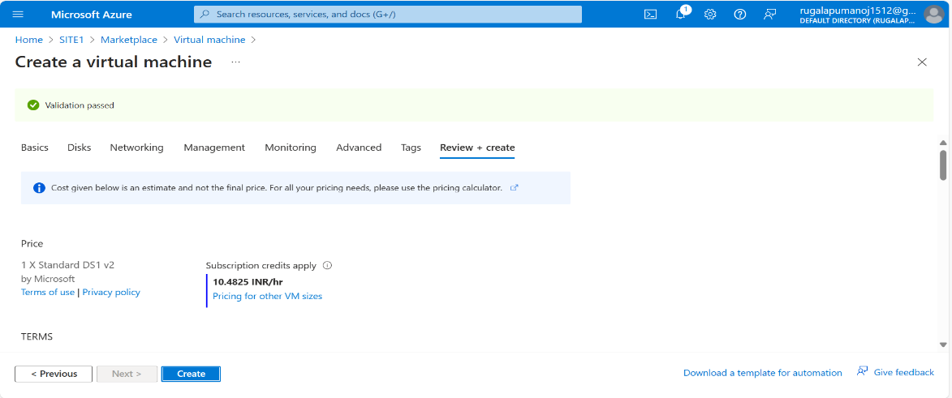

Create a Local Network Gateway:

* Create a local Network Gateway.
* Add IP Address from VM (RRAS).
* Add Address Space from DN server (ex : 192.168.0.0/16)

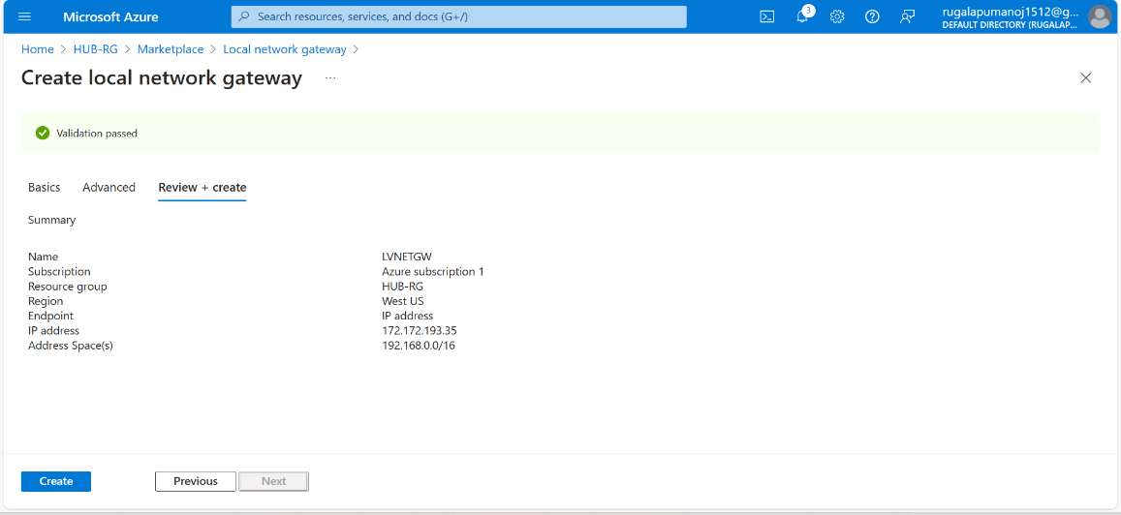

* “Overview” and click “connections”.

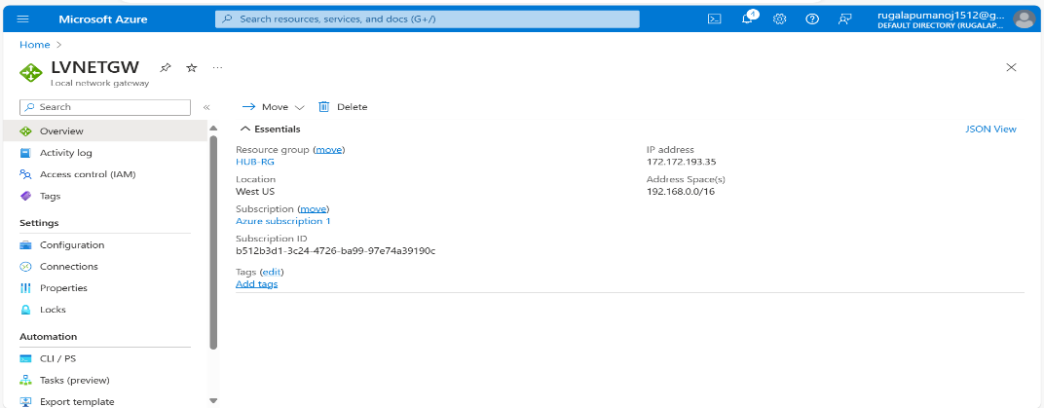

* Create a Connections.
* Fill the details and select your preferred region.
* Connection : site-to-site.
* Connect Between two virtual to local (Network Gateway).

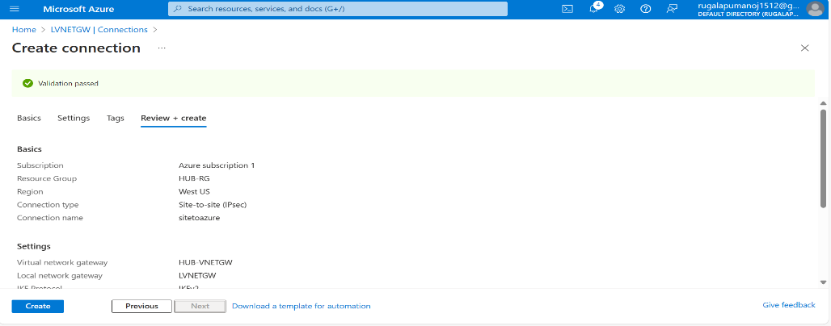

* Open once VM (RRAS).
* Then Connect it.

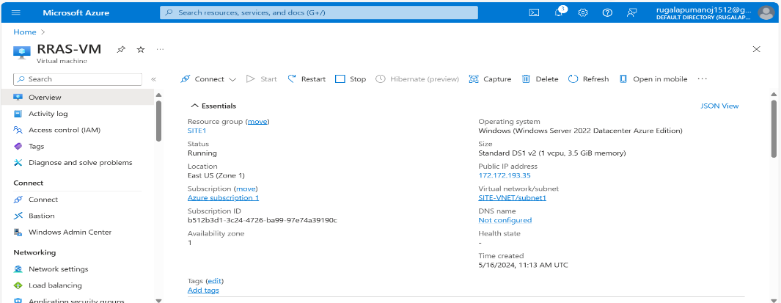

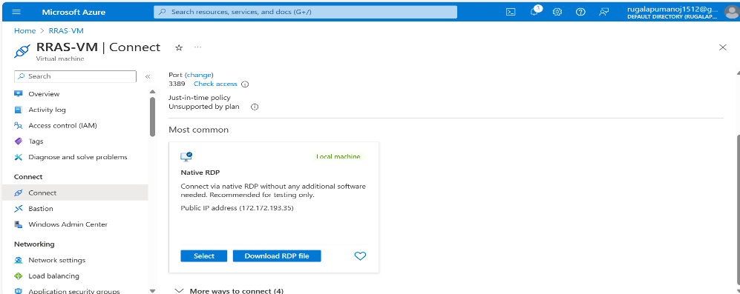

* Click “Download” RDP File.

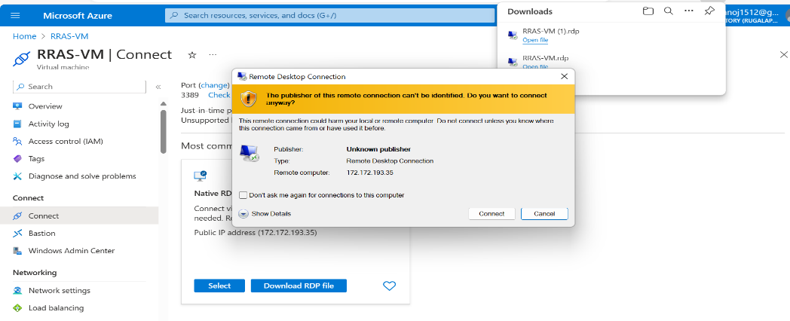

* Open the file RRAS.
* Remote desktop connection to connect it.

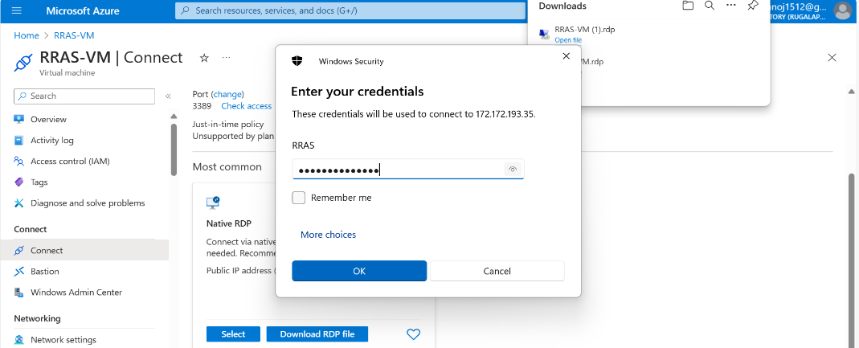

* Enter your credentials.

1. Username
2. Password

* Click it “OK”.
* Then open server manager in window server.

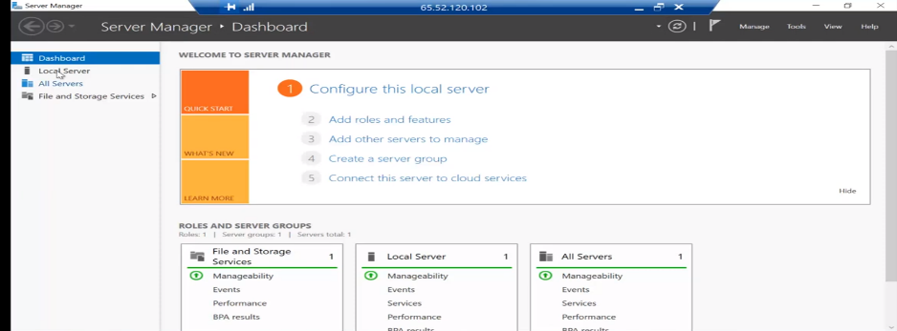

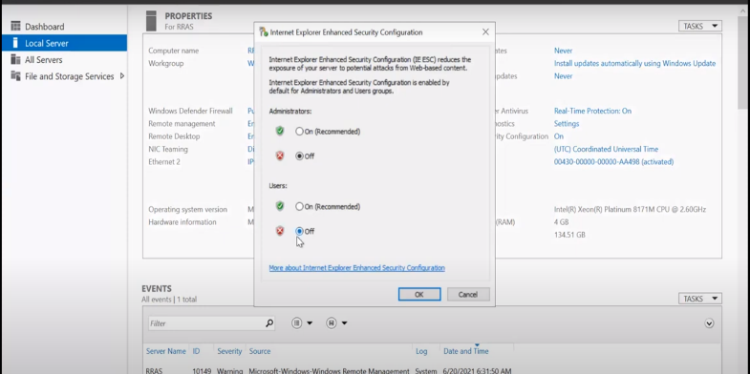

* Click Local Server, and enhanced security cong. Then Click Both (OFF ) button.
* Next firewall option will be off then Click ok.

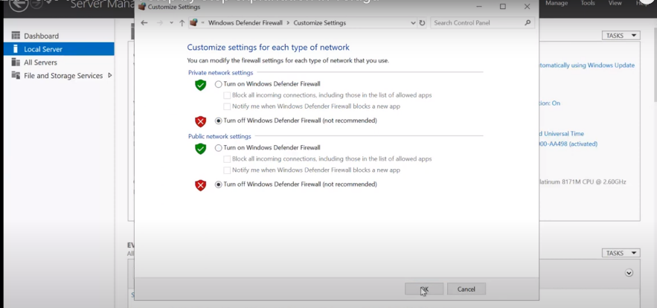

* GO to Dashboard we will add a roles and features.
* Click Next, add Remote Access then next.

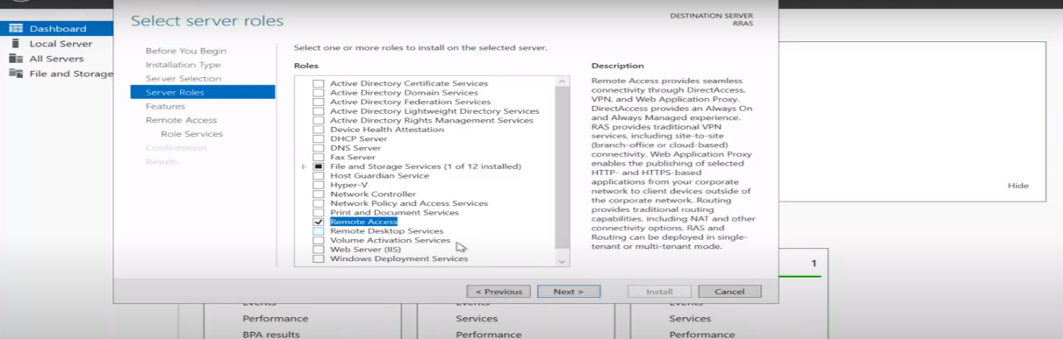

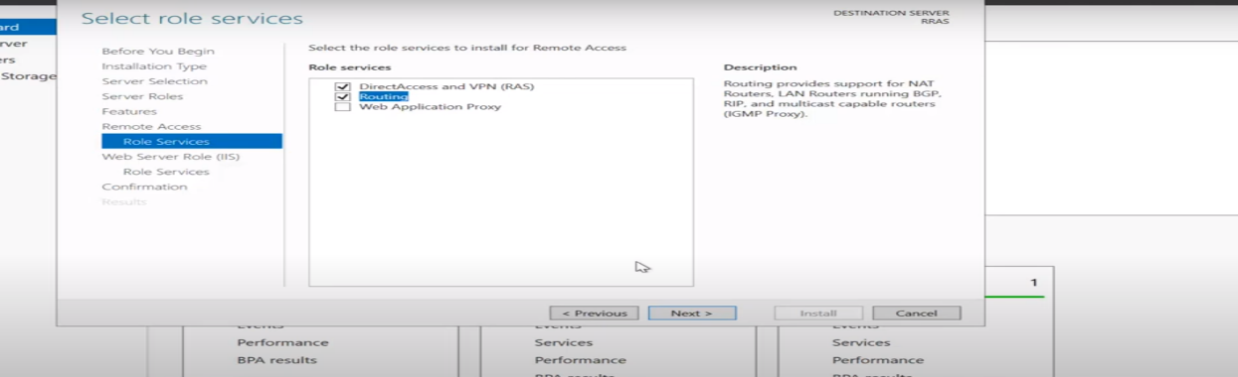

* Let we install as per given requirements. Then Click INSTALL.

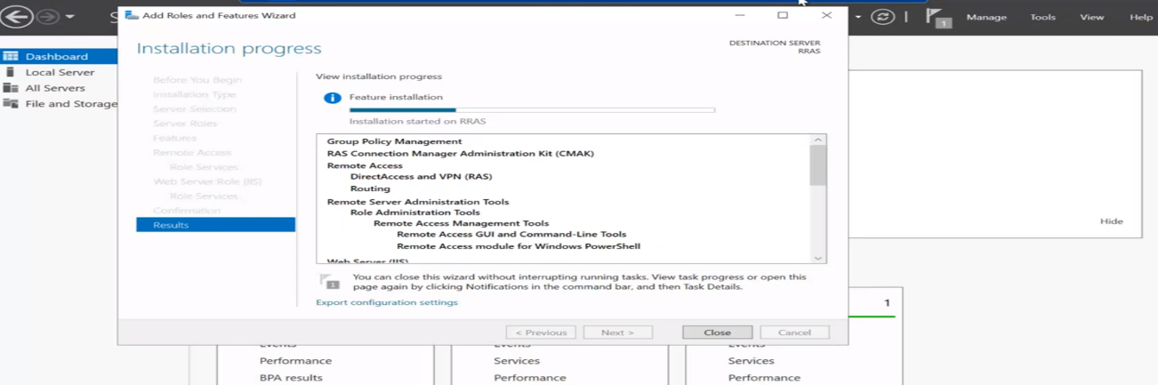

* Open Adminstrative Tools “Click ” routing and remote access.

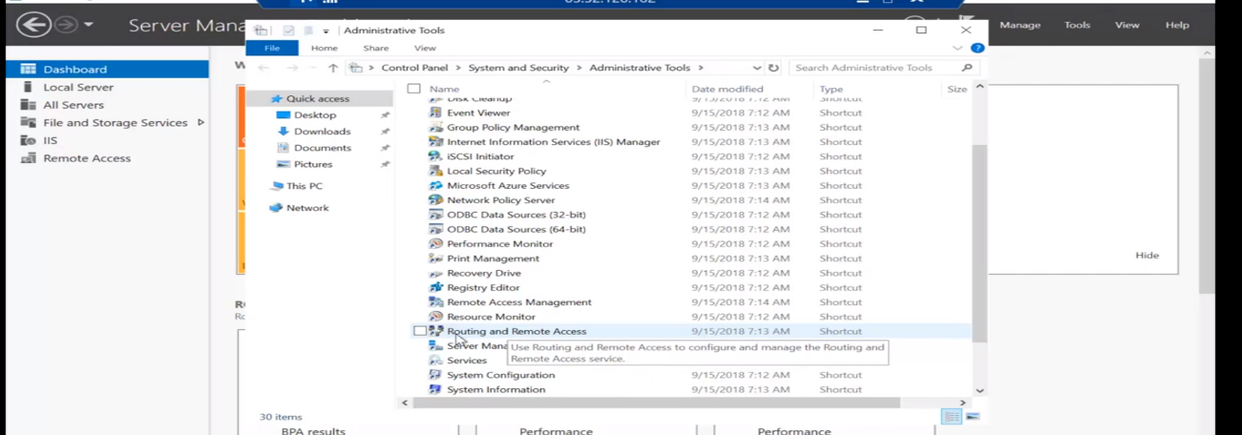

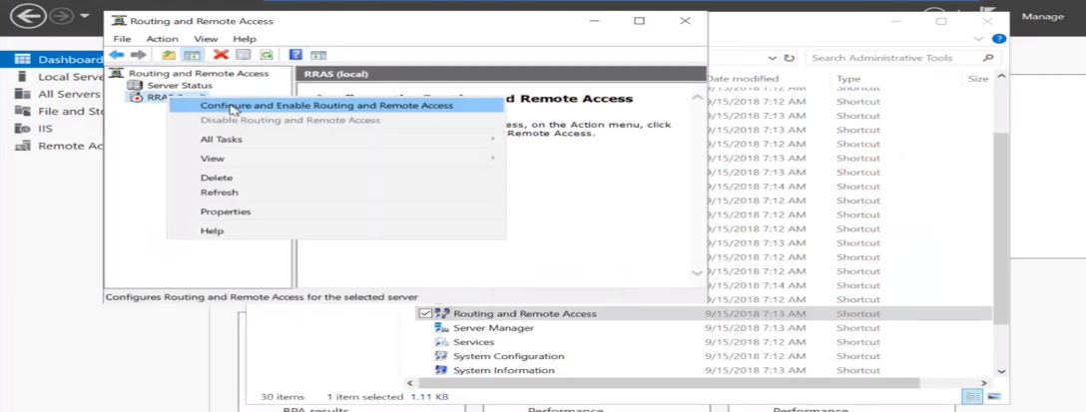

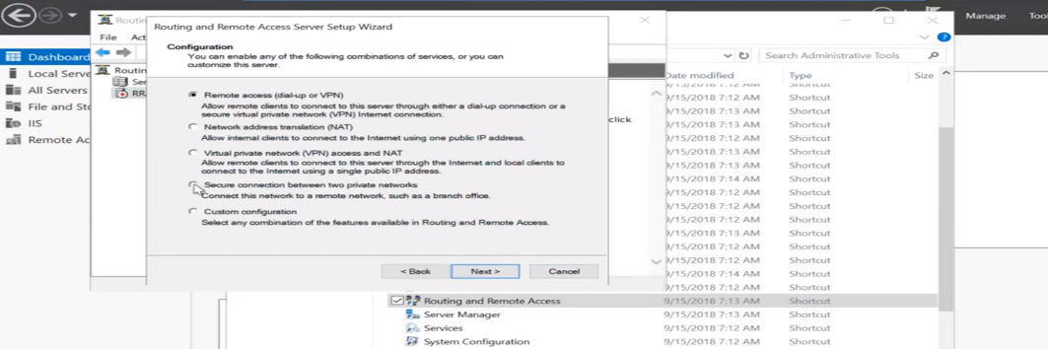

* Add a host Name ip. It will take a Azure network gateway.

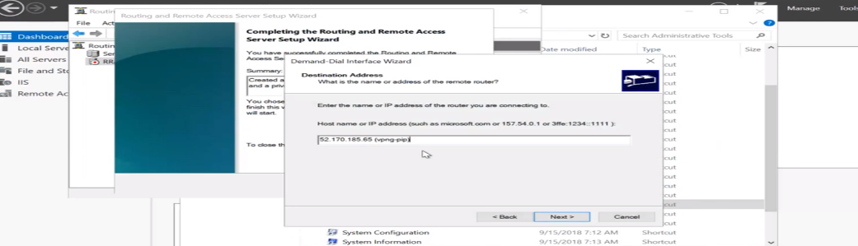

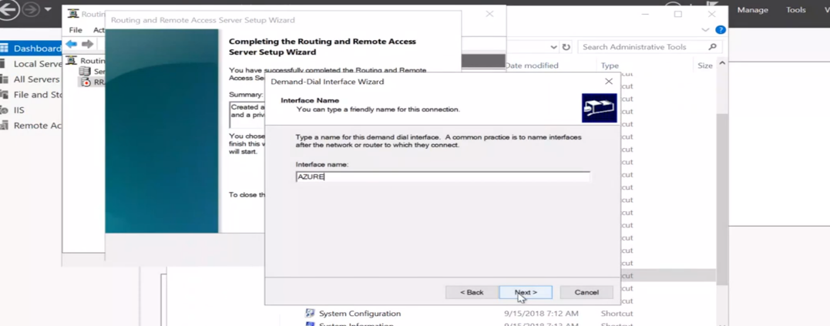

* Add a protocol VPN TYPE- IKEv2

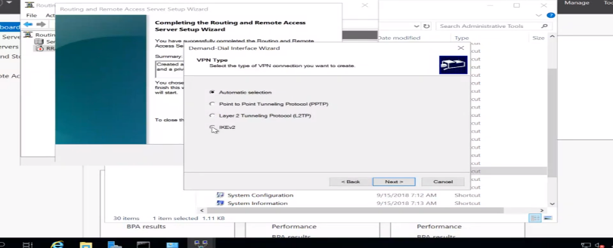

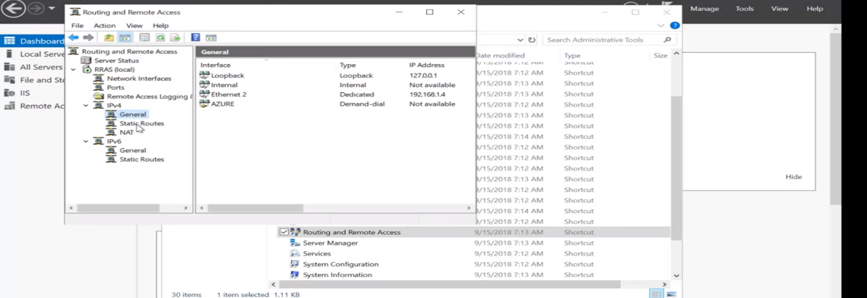

* Click static routers Then “Right Click” new.

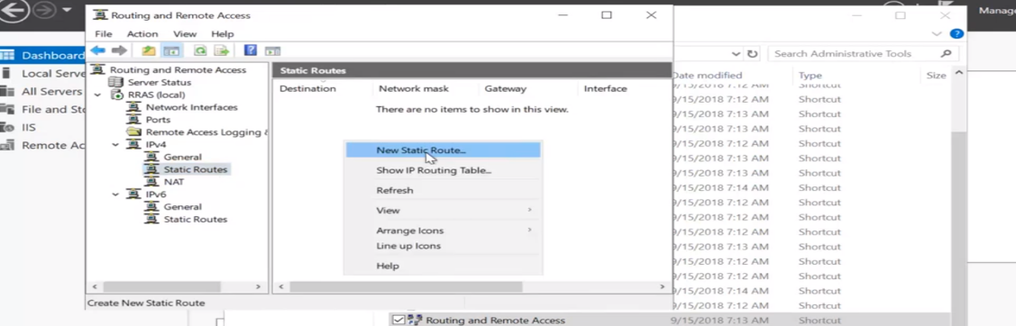

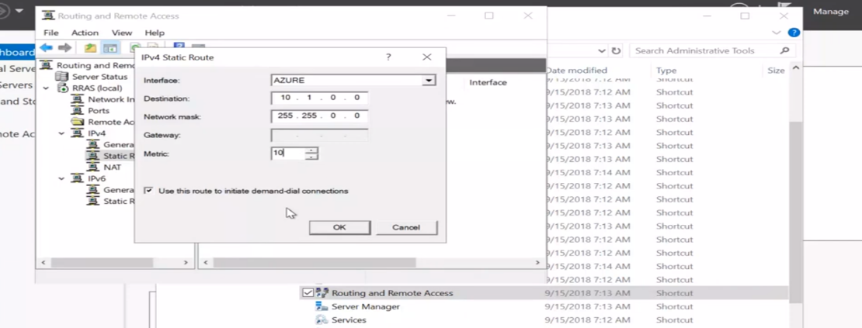

* Let we connect Site-site vpn.

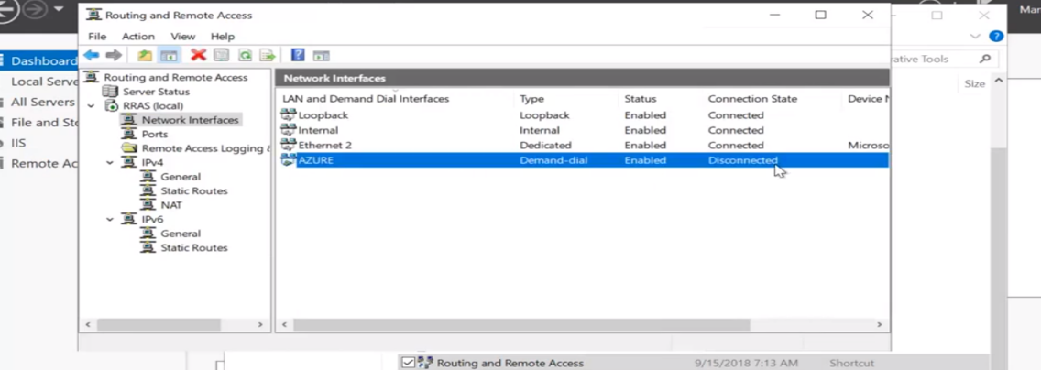

It’s not connected.

Create a connections:

* Create a connection in azure portal.

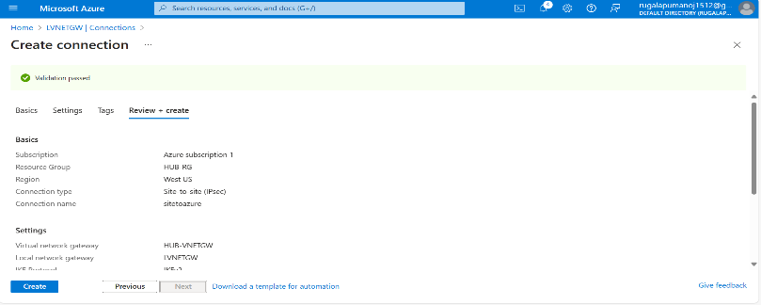

* Let open window server “Click ” CMD.
* Commad : ipconfig

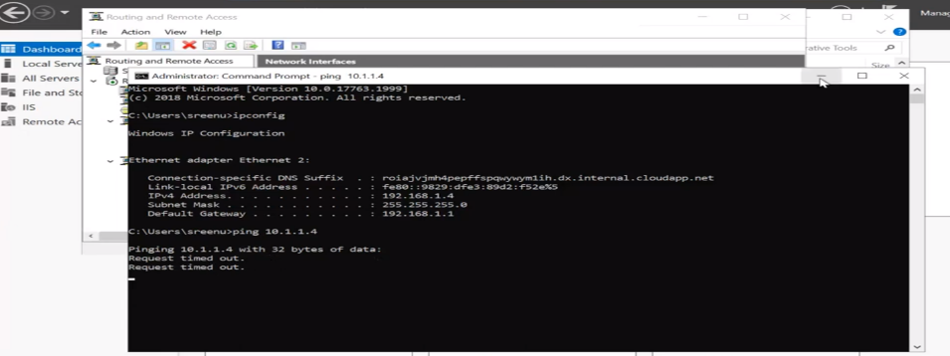

* Open azure then “Right ”Click and go to properties.

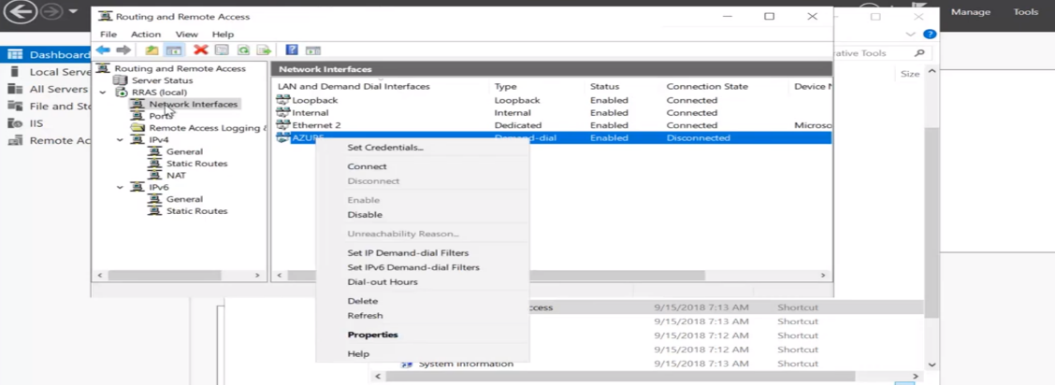

Then click security.

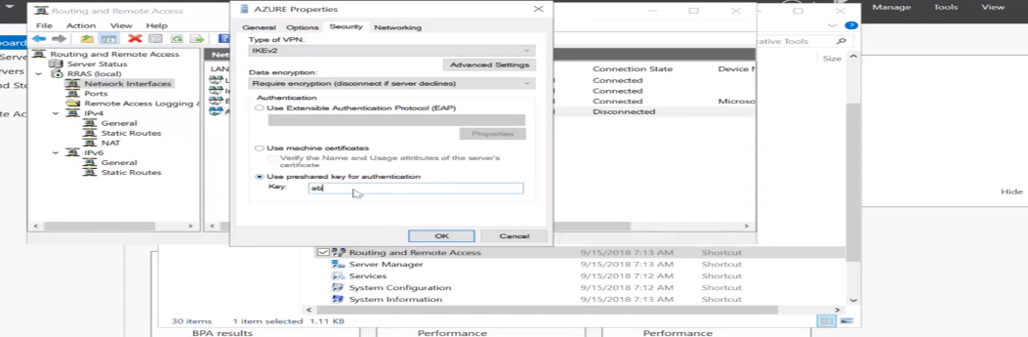

Yes It’s connected. And to verify use cmd.

Command : ipconfig, ping10.1.1.4

Its verified.

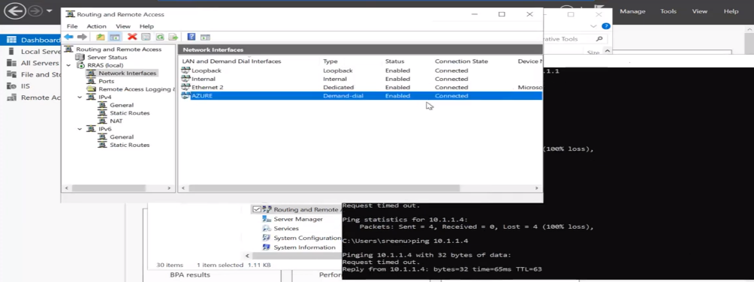

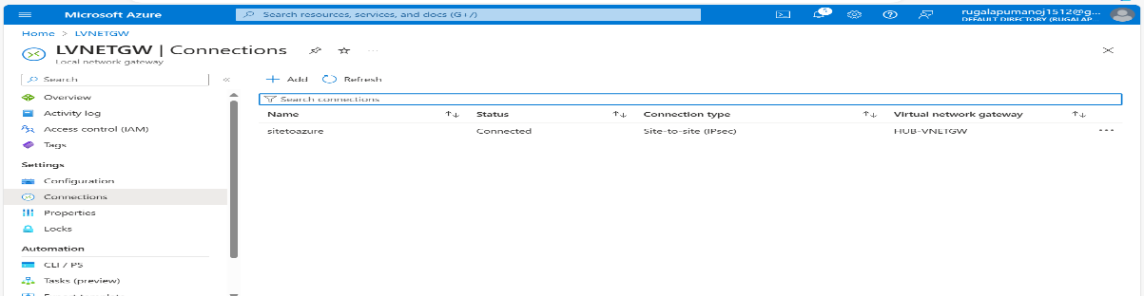

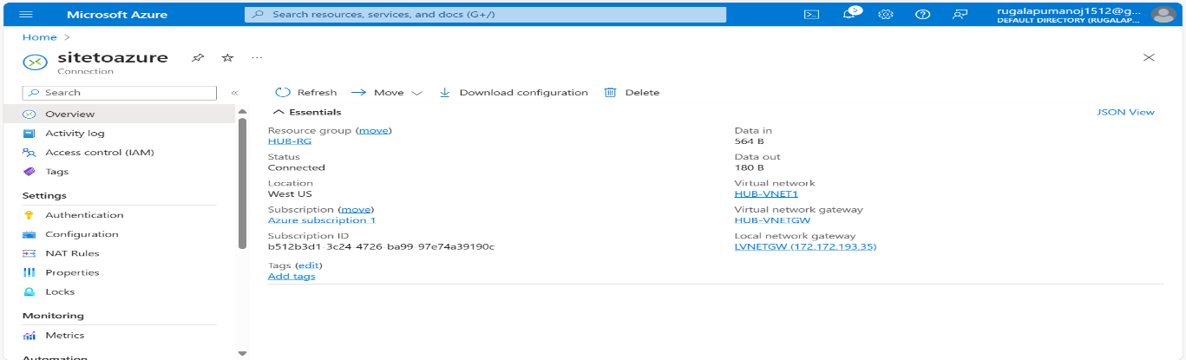

* It is Implemented and Verified Site-to-Site VPN Connection.